**DEPARTMENT OF COMPUTER & SOFTWARE ENGINEERING**

**COLLEGE OF E&ME, NUST, RAWALPINDI**

**Microprocessor and Microcontroller Based Design**

**Lab 01**

**SUBMITTED TO:**

**Dr Taimoor Zahid**

**SUBMITTED BY:**

**AMINA QADEER**

**Reg # 0000359607**

**DE-42 (C&SE)-A**

**Submission Date: 24/10/2022**

**Objectives:**

In this lab, you will be introduced to memory segmentation, and difference between physical and logical addresses of the memory. You will also deal with the different types of addressing modes and learn how to calculate the physical addresses from logical addresses. You will also write programs that will make use of loops and jump statements.

**Related Topic/Chapter in theory class:**

None

**Hardware/Software required:**

Hardware: PC

Software Tool: emu8086 v2.57

**Tasks:**

1. Write a program that takes a number input between 0 and 9 and then displays corresponding grade If grade is less than 5 it should display Grade C If grade is less than 7 it should display Grade B If grade is greater than or equal 7 it should display Grade A. The program should continue to run until user enters a negative number or a number greater than 9. Attach screenshot of all cases.

**Solution:**

org 100H

.STACK 100H

.DATA

PROMPT DB 13, 0ah, 'Enter a number between 0-9: $'

print1 DB 13, 0ah, 'A $' ,13, 0ah

print2 DB 13, 0ah, 'B $' ,13, 0ah

print3 DB 13, 0ah, 'C $' ,13, 0ah

.CODE

loop1:

MOV AX, @DATA ; initialize DS

MOV DS, AX

LEA DX,PROMPT ;ask uder prompt

MOV AH,9

INT 21H

mov ah,1

int 21h

mov CL,AL ;user input

sub CL, 30H

cmp cl , 0

jl exit

cmp cl, 10

jg exit

mov bl,5

cmp CL, BL ;initialize bh=7

jl C

mov BL, 7

cmp BL, CL

jle AGRADE

cmp CL, BL

jl B

exit:

mov ah,4ch

int 21h

;Result : ZF and CF set to ==> "ZF = 1" and "CF = 0"

;Result : ZF and CF set to ==> "ZF = 0" and "CF = 0"

AGRADE:

lea dx, print1 ;A if BL > BH =7

mov ah,9

int 21h

jmp loop1

;Result : ZF and CF set to ==> "ZF = 0" and "CF = 1"

B:

lea dx, print2 ;B if BL < BH =7

mov ah,9

int 21h

jmp loop1

C:

lea dx, print3 ;C if BL < BH =5

mov ah,9

int 21h

jmp loop1

ret

**Output:**

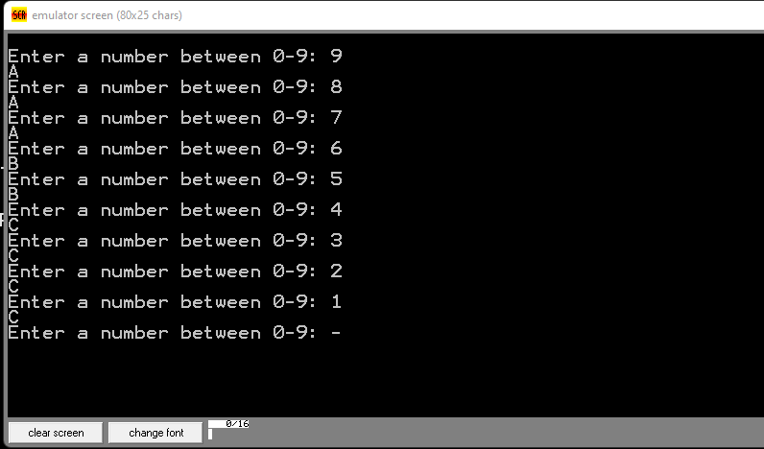

1. **Write a program that adds following series and places result in AX. => 95+90+85+…+5**

**Solution:**

1. org 100h
2. .data
3. .code
4. main proc
6. mov ax, 1
7. mov cx,95
8. mov bx, 0 ;This puts zero in AX
9. Label1:
10. add bx, cx
11. sub cx, 4 ; This adds int turn 1, 2, 3, ... ,10 to DX
12. loop Label1
14. end mainp

**Output:**

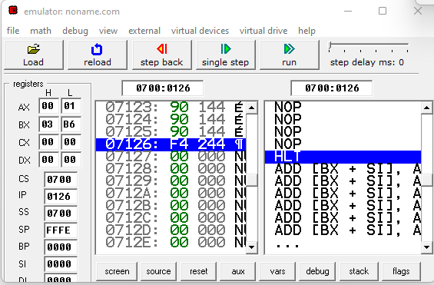

**Conclusion:**

The LOOP instruction is a combination of a DEC and JNZ instructions. It causes execution to branch to the address associated with the LOOP instruction.